**1st Table – runner_orders**

CREATE TABLE runner_orders(

order_id INT NOT NULL PRIMARY KEY,

runner_id INT NOT NULL,

pickup_time timestamp,

distance VARCHAR(7),

duration VARCHAR(10),

cancellation VARCHAR(23)

);

INSERT INTO runner_orders VALUES (1,1,”2021-01-01 18:15:34”,”20km”,”32 minutes”,NULL);

INSERT INTO runner_orders VALUES (2,1,”2021-01-01 19:10:54”,”20km”,”27 minutes”,NULL);

INSERT INTO runner_orders VALUES (3,1,”2021-01-03 00:12:37”,”13.4km”,”20 minutes”,NULL);

INSERT INTO runner_orders VALUES (4,2,”2021-01-04 13:53:03”,”23.4km”,”40 minutes”,NULL);

INSERT INTO runner_orders VALUES (5,3,”2021-01-08 21:10:57”,”10km”,”15 minutes”,NULL);

INSERT INTO runner_orders VALUES (6,3,NULL,NULL,NULL,”Restaurant Cancellation”);

INSERT INTO runner_orders VALUES (7,2,”2021-01-08 21:30:45”,”25km”,”25 minutes”,NULL);

INSERT INTO runner_orders VALUES (8,2,”2021-01-10 00:15:02”,”23.4 km”,”15 minutes”,NULL);

INSERT INTO runner_orders VALUES (9,2,NULL,NULL,NULL,”Customer Cancellation”);

INSERT INTO runner_orders VALUES (10,1,”2021-01-11 18:50:20”,”10km”,”10 minutes”,NULL);

desc runner_orders;

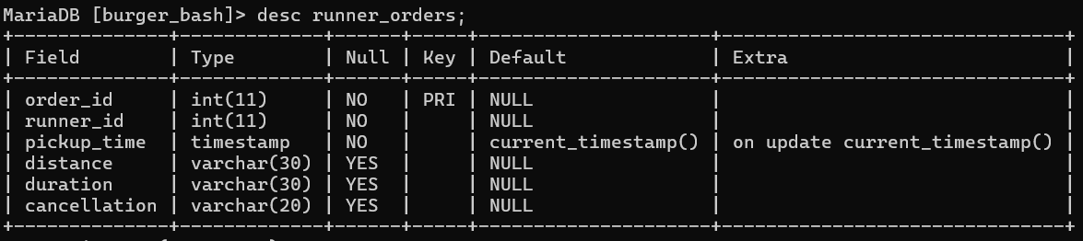

Select* from runner_orders;

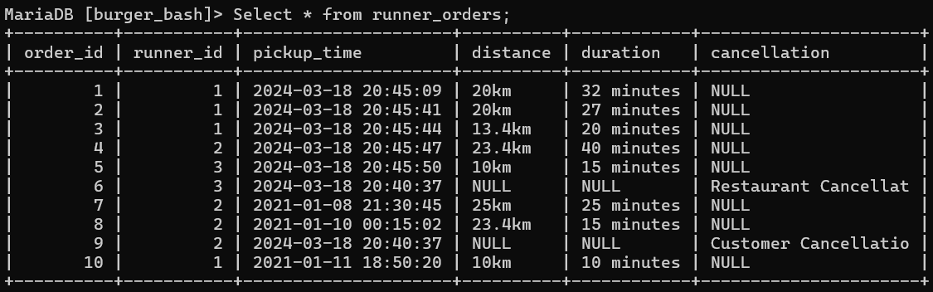

**2nd Table – burger_names**

CREATE TABLE burger_names(

burger_id INT NOT NULL PRIMARY KEY,

burger_name VARCHAR(10) NOT NULL

);

INSERT INTO burger_names(burger_id,burger_name) VALUES (1,”Meatlovers”);

INSERT INTO burger_names(burger_id,burger_name) VALUES

(2,”Vegetarian”);

desc burger_names;

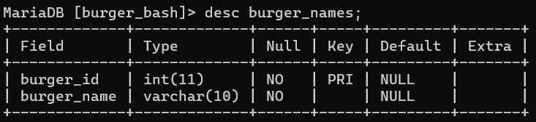

Select * from burger_names;

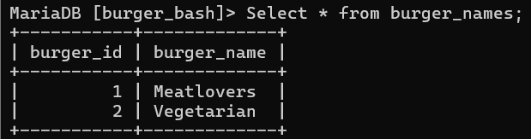

**3rd Table – burger_runner**

CREATE TABLE burger_runner(

runner_id int NOT NULL PRIMARY KEY,

registration_date date NOT NULL

);

INSERT INTO burger_runner VALUES (1,”2021-01-01”);

INSERT INTO burger_runner VALUES (2,”2021-01-03”);

INSERT INTO burger_runner VALUES (3,”2021-01-08”);

INSERT INTO burger_runner VALUES (4,”2021-01-15”);

desc burger_runner;

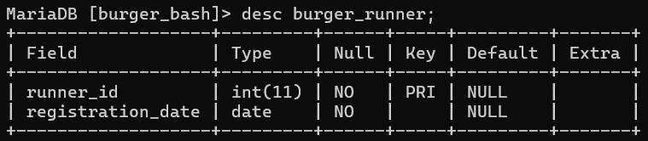

select * from burger_runner;

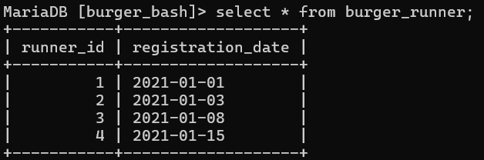

**4th Table – customer_orders**

CREATE TABLE customer_orders(

order_id INT NOT NULL,

customer_id INT NOT NULL,

burger_id INT NOT NULL,

exclusions VARCHAR(4),

extras VARCHAR(4),

order_time timestamp NOT NULL

);

INSERT INTO customer_orders VALUES (1,101,1,NULL,NULL,”2021-01-01 18:05:02”);

INSERT INTO customer_orders VALUES (2,101,1,NULL,NULL,”2021-01-01 19:00:52”);

INSERT INTO customer_orders VALUES (3,102,1,NULL,NULL,”2021-01-02 23:51:23”);

INSERT INTO customer_orders VALUES (3,102,2,NULL,NULL,”2021-01-02 23:51:23”);

INSERT INTO customer_orders VALUES (4,103,1,”4”,NULL,”2021-01-04 13:23:46”);

INSERT INTO customer_orders VALUES (4,103,1,”4”,NULL,”2021-01-04 13:23:46”);

INSERT INTO customer_orders VALUES (4,103,2,”4”,NULL,”2021-01-04 13:23:46”);

INSERT INTO customer_orders VALUES (5,104,1,NULL,”1”,”2021-01-08 21:00:29”);

INSERT INTO customer_orders VALUES (6,101,2,NULL,NULL,”2021-01-08 21:03:13”);

INSERT INTO customer_orders VALUES (7,105,2,NULL,”1”,”2021-01-08 21:20:29”);

INSERT INTO customer_orders VALUES (8,102,1,NULL,NULL,”2021-01-09 23:54:33”);

INSERT INTO customer_orders VALUES (9,103,1,”4”,”1, 5”,”2021-01-10 11:22:59”);

INSERT INTO customer_orders VALUES (10,104,1,NULL,NULL,”2021-01-11 18:34:49”);

INSERT INTO customer_orders VALUES (10,104,1,”2, 6”,”1, 4”,”2021-01-11 18:34:49”);

desc customer_orders;

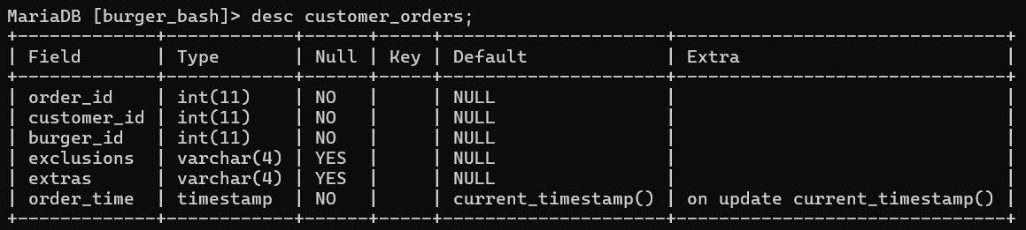

Select * from customer_orders;

